|  |  |
| --- | --- |
| EGC_Black | Student Name \_\_\_\_\_\_\_\_\_\_\_\_\_\_\_\_\_\_\_\_\_\_\_    **Eastern Goldfields College**  Mathematics Essential U1 2017  Test 2 – Calculator Free Section1 |
|  | Total Marks: 18 Marks |

Time allowed: 15 minutes

**No calculator or notes permitted for this section.**

***Answer all of the following questions. Show working where necessary.***

**Question 1** [3 Marks – 1, 2]

1. Which is the correct abbreviation for 90 kilometres?

90 kms or 90 km (circle the correct answer)

(b) Which unit, millimetre, centimetre, metre or kilometre, would you use to measure each of these lengths?

1. The length of your table \_\_\_\_\_\_\_\_\_\_\_\_\_\_\_
2. The width of a finger nail \_\_\_\_\_\_\_\_\_\_\_\_\_\_\_
3. The length of a football oval \_\_\_\_\_\_\_\_\_\_\_\_\_\_\_
4. The distance from Kalgoorlie to Melbourne \_\_\_\_\_\_\_\_\_\_\_\_\_\_\_

**Question 2** [7 Marks – 1, 1, 1, 1, 1, 1, 1]

Convert the following units:

a) 3 m = \_\_\_\_\_\_\_\_\_\_\_\_\_ cm b) 5.35 km = \_\_\_\_\_\_\_\_\_\_\_\_ m

c) 4000 m = \_\_\_\_\_\_\_\_\_\_\_\_km d) 23 cm = \_\_\_\_\_\_\_\_\_\_\_\_\_mm

e) 2 cm2 = \_\_\_\_\_\_\_\_\_\_\_\_\_\_mm2 f) 3 km2 =\_\_\_\_\_\_\_\_\_\_\_\_\_\_\_m2

g) 1 m2 = \_\_\_\_\_\_\_\_\_\_\_\_\_\_\_\_cm2

**Question 3** [4 Marks – 1, 1, 2]

Calculate the perimeter of the following shapes:

[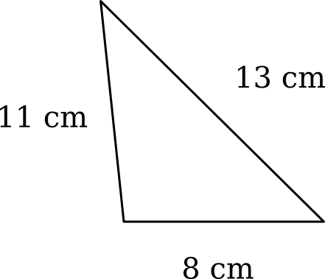](https://www.google.com.au/url?sa=i&rct=j&q=&esrc=s&source=images&cd=&cad=rja&uact=8&ved=0ahUKEwjI18GOqNPSAhUBSJQKHSR2BW0QjRwIBw&url=https://www.varsitytutors.com/isee_lower_level_math-help/how-to-find-the-perimeter-of-a-triangle&psig=AFQjCNFvX0HuL6LPxeEcuFffjGhFJagKYw&ust=1489488742282204)(a) (b)

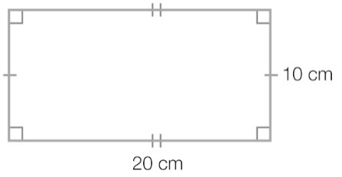

(c)

**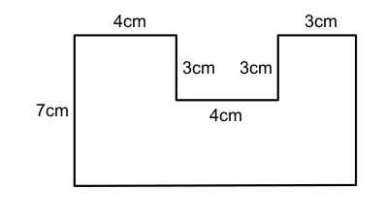**

**Question 4** [2 Marks]

Draw a possible rectangle with a perimeter of 14 cm. Clearly label the length and width.

**Question 5** [2 Marks]

The height of Simon’s kitchen bench top is 900 mm.

1. Is this less than or more than 1 m?
2. How many centimetres difference between 900 mm and 1 m?

|  |  |
| --- | --- |
| EGC_Black | Student Name \_\_\_\_\_\_\_\_\_\_\_\_\_\_\_\_\_\_\_\_\_\_\_    **Eastern Goldfields College**  Mathematics Essential U1 2017  Test 2 – Calculator Assumed1 |
| Time allowed: 40 minutes | Total Marks: 42 marks |

**One A4 page of notes permitted in this section. Show working to maximise your marks.**

**Question 1** [8 Marks – 2, 2, 4]

1. John plays cricket. If John can bowl 6 balls in 5 minutes. How many balls can he bowl  
    in ½ hour?
2. At Coles you have a choice of buying loose potatoes or a bag of potatoes. Loose potatoes cost

$2.30 per kg and a 3 kg bag of potatoes is $7. Which is the better buy? **Show your working to justify your answer.**

1. James earns $23.50 an hour and works a normal 37-hour week. In the same week, he works 10 hours overtime at time and a half and 4 hours overtime at double time how much does he earn in the week?

**Question 2** [5 marks - 2, 3]

Taxi fares (T dollars) have several components: flagfall (f), booking fee (b), waiting fee (w) and a ‘per kilometre’ charge (m).

T = f + b + w + 1.69m

The Kalgoorlie taxi company charges

$3.00 flagfall

$2.00 booking fee

$9.50 for each 10 minutes (or part thereof)\* of waiting time

$1.88 per kilometre

\*part thereof means you pay $9.50 for every 10 minute block of time even if you only wait for part of it.

You only pay the booking fee if you book a taxi by telephone or online.

You only pay the waiting fee if the driver has to wait 10 minutes or more.

1. What would be the taxi fare for a customer who hailed a taxi on Friday at 11am, hopped in straight away and travelled to an appointment 25 kms away.
2. Another customer booked a taxi on Thursday morning. When it arrived he asked the driver to wait. He left 28 minutes later for a journey of 32 km.

**Question 3** [4 Marks – 2, 2]

Estimate the area of the following shapes each square represents 1 unit2

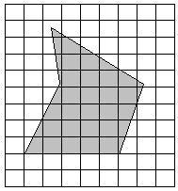[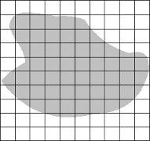](https://www.google.com.au/url?sa=i&rct=j&q=&esrc=s&source=images&cd=&cad=rja&uact=8&ved=0ahUKEwj39OPOqPPSAhUGVZQKHZnbAQsQjRwIBw&url=http://www.math-mate.com/chapter28_1.shtml&bvm=bv.150729734,d.dGo&psig=AFQjCNEl5lWfwFiBpwZKZkWYUdO200mWFg&ust=1490588371348964)(a)

(b)

**Question 4** [7 Marks – 1, 1, 2, 3]

[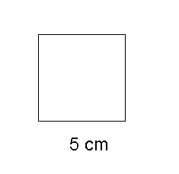](https://www.google.com.au/url?sa=i&rct=j&q=&esrc=s&source=images&cd=&cad=rja&uact=8&ved=0ahUKEwjdkZnQyfbSAhVIw1QKHcDYBr8QjRwIBw&url=http://www.mathsmutt.co.uk/files/carea.htm&psig=AFQjCNF-bzj6EZ_f-Q4vF-ZHvDaWO-yt4A&ust=1490700294952361)[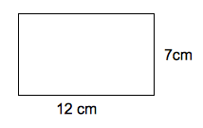](https://www.google.com.au/url?sa=i&rct=j&q=&esrc=s&source=images&cd=&cad=rja&uact=8&ved=0ahUKEwiV1YLnyfbSAhXlrlQKHShjAvwQjRwIBw&url=http://www.varsitytutors.com/basic_geometry-help/how-to-find-the-area-of-a-rectangle&bvm=bv.150729734,d.cGw&psig=AFQjCNGGtWand_X8p4vkRx3uyu3PCx7e1w&ust=1490700376018179)Calculate the area of the following shapes:

(a) (b)

[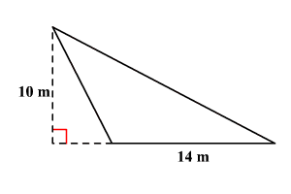](https://www.google.com.au/url?sa=i&rct=j&q=&esrc=s&source=images&cd=&cad=rja&uact=8&ved=0ahUKEwjfjL7-yfbSAhVIw1QKHcDYBr8QjRwIBw&url=https://www.varsitytutors.com/hotmath/hotmath_help/topics/area-of-triangle&bvm=bv.150729734,d.cGw&psig=AFQjCNEXfpulrZauo3m1QKShOxPOwHAdaQ&ust=1490700424510623)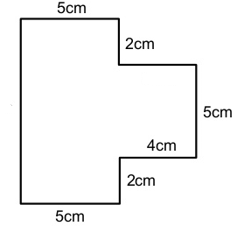

(c) (d)

**Question 5** [3 Marks]

Find the area of the shaded region:

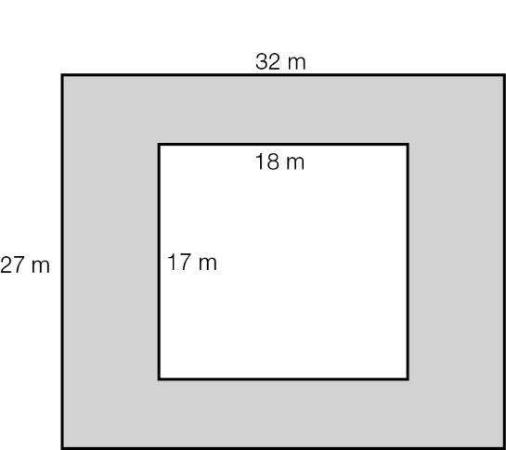

**Question 6** [3 Marks – 1, 2]

(a) Find the width of the given rectangle.

(b) Find the height of the given triangle.

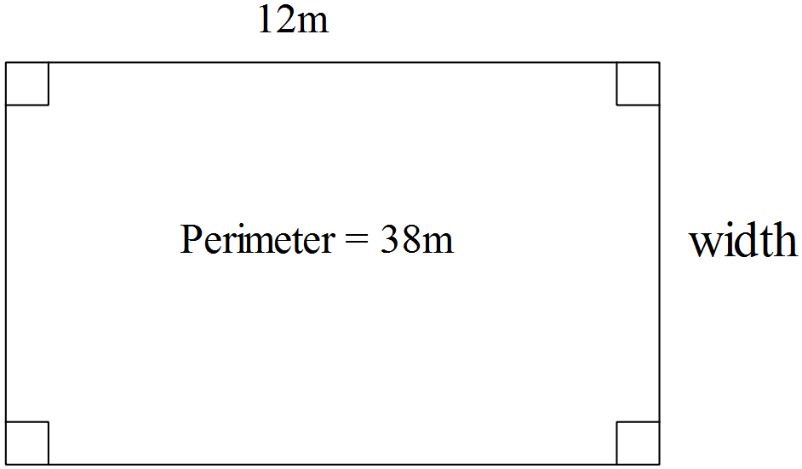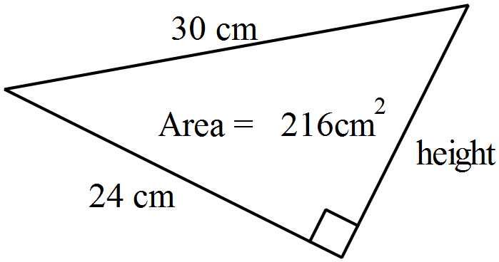

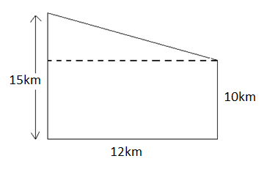**Question 7** [8 marks- 2, 1, 2, 3]

1. Find the area of the plot of land to the right:
2. Convert the units from km2 to m2
3. An acre is an old measure of land area, which equals approximately 4 047m2. How many acres

in the plot of land above? Give your answer to the nearest acre.

1. A hectare (ha) is a unit of area that measures 100m by 100m as shown in the diagram below.

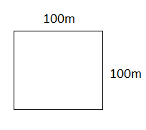

1. How many square meters in a hectare?
2. How many acres are in a hectare? Give your answer to 1 d.p.

**Question 8** [4 marks – 3, 1]

(a) A paving brick measures 230 mm long and 115 mm wide. Show, using calculations, how approximately 38 pavers will be needed to cover 1 m2

(b) How many pavers will be needed to cover an area of 120 m2?

END OF TEST